Conditional Workflows in LangGraph
CampusX | Agentic AI using LangGraph | Video 7
Duration: 47:38
Watch: https://www.youtube.com/watch?v=I-dvZqTz-Wc
Official notebooks: https://github.com/campusx-official/langgraph-tutorials
Core idea: A decision function reads the current graph state, then chooses which node executes next. Think of a graph-shaped if / elif / else.
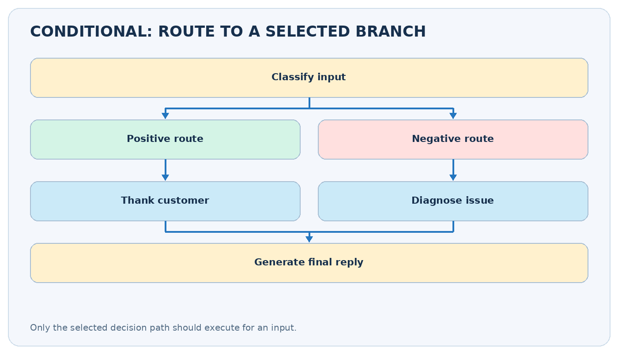
Conditional routing overview

Video chapters — clickable timestamps
- 00:00 — Recap: earlier workflow types
- 04:38 — Conditional workflow / quadratic equation example
- 24:20 — LLM review handling example
These are chapter start times, so an explanation may continue until the next chapter.

Learning outcomes
- Distinguish sequential, parallel and conditional execution.
- Write state schemas, calculation nodes and a routing function.
- Use add_conditional_edges and an explicit path map.
- Understand structured LLM classifications for customer-review routing.
- Handle missing inputs and edge cases without allowing an undefined route.

1. What is conditional execution?
In a sequential workflow, every run follows the same ordered steps. In parallel, several independent tasks are scheduled together. In a conditional graph, the value of a field determines which successor executes. An example is START → classify_review → [thank_you OR diagnose_issue] → END.
Imagine customer support: a payment problem goes to billing, an account problem to access support, and a compliment to the thank-you responder. You would not invoke all three responses for one review.
Two concepts that are easy to confuse: A router function makes a decision from state ("positive", "negative", "unknown"); a conditional edge uses that decision to activate its target. The router should ideally be cheap, deterministic and free of side effects.

2. Minimal graph vocabulary
Building block | What it does | Example
State (TypedDict) | Defines input and intermediate fields | review text, sentiment, response
Worker node | Computes/produces partial updates | return {"sentiment": "positive"}
Router function | Reads state, returns a route label | return state["sentiment"]
add_conditional_edges | Maps labels to next nodes | positive → thank; negative → diagnose
END | Completes selected path | no more work is scheduled
An ordinary add_edge("A", "B") makes a fixed transition. For a decision after A, use add_conditional_edges("A", router, paths).

3. Example 1: quadratic-equation solver
Watch at 04:38
For a*x² + b*x + c = 0, first calculate the discriminant D = b² - 4ac. Then route according to the value:
Test | Meaning | Correct computation
D > 0 | Two distinct real roots | (-b ± sqrt(D)) / (2a)
D == 0 | One repeated real root | -b / (2a)
D < 0 | No real roots | Explain that roots are complex
If a == 0, it is not a quadratic equation. Validate the input before calculating roots.
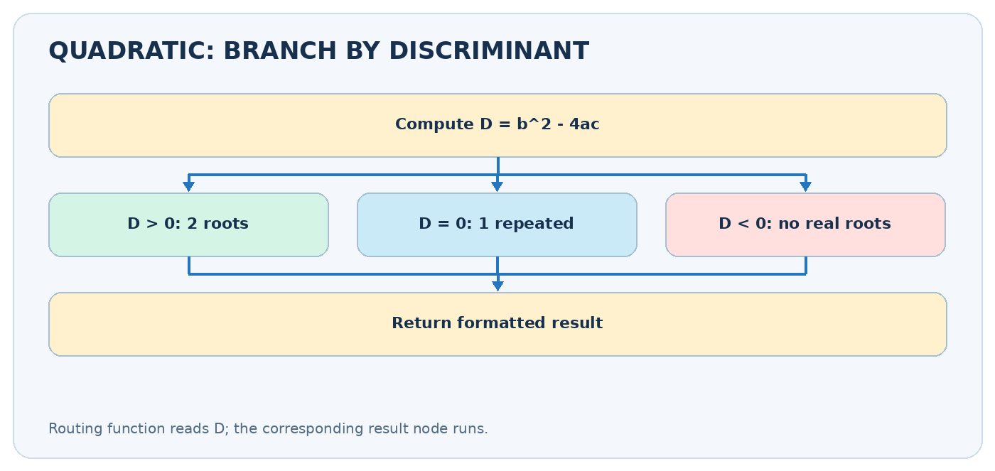
Quadratic conditional paths

Complete runnable graph (no API key)
from typing import TypedDict, NotRequired
from math import sqrt
from langgraph.graph import StateGraph, START, END
class QuadState(TypedDict):
a: float
b: float
c: float
discriminant: NotRequired[float]
result: NotRequired[str]
def discriminant(state: QuadState) -> dict:
if state["a"] == 0:
return {"discriminant": float("nan")}
return {"discriminant": state["b"] ** 2 - 4 * state["a"] * state["c"]}
def route(state: QuadState) -> str:
if state["a"] == 0:
return "invalid"
d = state["discriminant"]
return "two" if d > 0 else "one" if d == 0 else "complex"
def two_roots(state: QuadState) -> dict:
a, b, d = state["a"], state["b"], state["discriminant"]
r1, r2 = (-b + sqrt(d)) / (2*a), (-b - sqrt(d)) / (2*a)
return {"result": f"Two real roots: {r1:.3g}, {r2:.3g}"}
def one_root(state: QuadState) -> dict:
return {"result": f"Repeated root: {-state['b']/(2*state['a']):.3g}"}
def complex_roots(state: QuadState) -> dict:
return {"result": "No real roots; discriminant is negative."}
def invalid(state: QuadState) -> dict:
return {"result": "a must not be zero for a quadratic equation."}
builder = StateGraph(QuadState)
builder.add_node("compute", discriminant)
builder.add_node("two", two_roots)
builder.add_node("one", one_root)
builder.add_node("complex", complex_roots)
builder.add_node("invalid", invalid)
builder.add_edge(START, "compute")
builder.add_conditional_edges(
"compute", route,
{"two":"two", "one":"one", "complex":"complex", "invalid":"invalid"},
)
for node in ("two", "one", "complex", "invalid"):
builder.add_edge(node, END)
app = builder.compile()
for coeffs in [(1, -3, 2), (1, 2, 1), (1, 0, 1), (0, 2, 1)]:
print(coeffs, app.invoke(dict(zip(("a", "b", "c"), coeffs)))["result"])
How the route works: with (a,b,c)=(1,-3,2), D=9-8=1, so the two node runs and returns roots 2 and 1. With (1,2,1), D=0, so only one executes. This is selection, not parallelism.

4. Example 2: customer-review response using an LLM
Watch at 24:20
A review arrives, e.g., “Great interface!” or “The checkout crashes and I need urgent help.” A classification model chooses positive or negative. In the negative branch, a diagnosis step extracts issue_type, urgency, and tone; a response writer uses that diagnosis to respond appropriately.
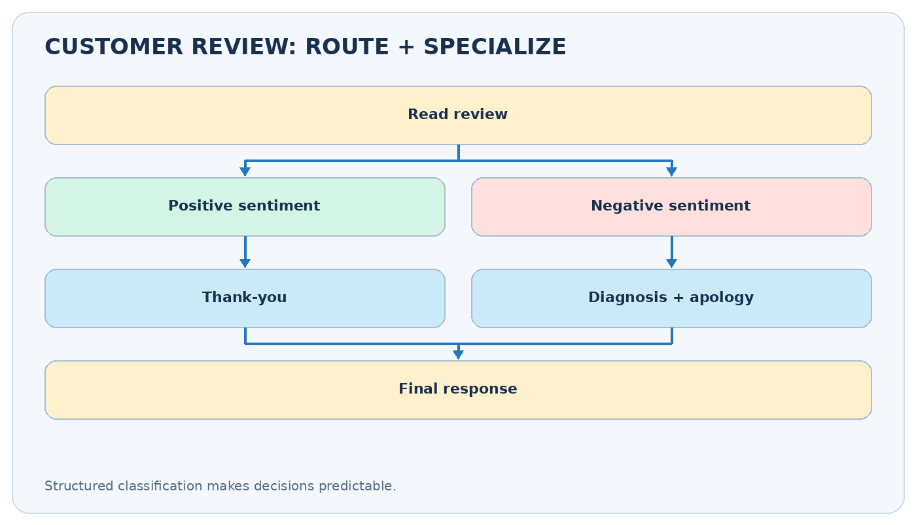
Review handling graph

Pydantic structured-output concept
from typing import Literal
from pydantic import BaseModel, Field
class Sentiment(BaseModel):
label: Literal["positive", "negative"]
class Diagnosis(BaseModel):
issue_type: Literal["bug", "ux", "performance", "support", "other"]
urgency: Literal["low", "medium", "high"]
tone: str = Field(description="How the customer sounds")
# With an initialized compatible chat model:
# classifier = model.with_structured_output(Sentiment)
# outcome = classifier.invoke("Classify the review: ...")
# node returns {"sentiment": outcome.label}
An LLM’s free-form answer can be hard to route; a structured, validated label makes it easier. Still, handle classification errors, unexpected labels, model timeouts and ambiguous feedback. For severe complaints, include escalation to a human rather than inventing a resolution.

Routes as business rules
Review | Classifier output | Action
“Great support team” | positive | Generate short thanks
“App crashes every login” | negative | Diagnose bug / prioritize
“I love the features but billing failed” | ambiguous | Define policy; possibly add mixed/triage route
Design tip: if there are more than two possible classes, introduce a Literal["positive", "negative", "mixed"] and a third path rather than forcing a misleading binary decision.

5. Conditional edges vs several normal edges
If you add both A -> B and A -> C as ordinary outgoing edges, both B and C can be scheduled. That is not equivalent to an if/else decision. Use conditional routing to select one path.
def decide(state) -> str:
return "refund" if state["intent"] == "refund" else "support"
builder.add_conditional_edges(
"classify", decide,
{"refund": "refund_handler", "support": "support_handler"},
)
When several routes reconverge at a shared finishing node, make sure every selected route reaches it, or explicitly goes to END.

6. Debugging checklist
Symptom | Likely cause | Remedy
Route label has no target | Output not in path mapping | Add mapping/default or validate label
Every branch executes | Used ordinary edges for branching | Replace with conditional edges
KeyError in router | State key not set | Ensure classifier updates key before routing
Unexpected LLM route | No constrained output | Use Literal / schema and validation
Wrong math branch | Equality / floating-point issue | For approximate computations, use tolerance
Production caution: route labels should be treated like untrusted data if derived from an LLM; validate before using them to authorize money transfers, data deletion or account changes.

7. Exercises
- Extend the quadratic workflow to calculate complex roots using cmath.sqrt.
- Add a mixed review route and a human_escalation route.
- Add a node that logs the chosen route and timestamps each decision.
- Test all possible paths separately; a successful happy-path test does not prove the entire graph is correct.

Quick revision
- ☐ I can distinguish branching from parallel fan-out.
- ☐ I can write a route function that reads graph state.
- ☐ I can explain why add_conditional_edges is different from add_edge.
- ☐ I can run the no-key quadratic solver.
- ☐ I can explain why structured classification helps with LLM routing.
- ☐ I can describe what happens when a route label is unexpected.
Related source code: Quadratic equation notebook and review reply notebook.
Further reading: Official LangGraph Graph API.

